**Examine the following example of a two-column proof argument:**

|  |  |
| --- | --- |
| **Statements** | **Reasons** |
|  | 1. Given |
|  | 1. Addition Property of Equality |
|  | 1. Multiplication Property of Equality |

**Following, is an example of this proof in a flow chart format:**

**IF**



Addition Property of Equality

Multiplication Property of Equality

**THEN**

**IF**

**THEN**

* A proof is a series of SPECIFIC CONJECTURES.
* Each statement serves as the HYPOTHESIS for the statement that follows. The statement that follows is the CONCLUSION.
* Your job is to find the GENERALIZATION of the SPECIFIC CONJECTURE.
* The statements you write are examples of the **definitions, postulates or theorems** you have studied.
* The name of the definition, postulate or theorem is what goes in the REASONS column.
* This reason justifies what is happening in the statements of the proof

**Use the diagram below for the following exercises.**

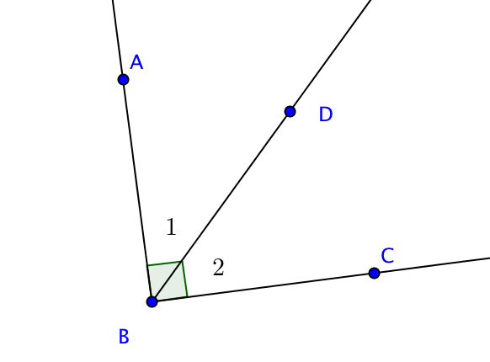

|  |  |
| --- | --- |
| **A.**  **General Statement:**  If two angles are complementary, then their sum is 90 degrees.  **Specific Conjecture:**  **If** is complementary to , **then**______________________.  **Reason:** | **B.**  **General Statement:**  If the measures of two smaller adjacent angles are added together, their sum is the measure of the larger angle formed by their non-adjacent sides.  **Specific Conjecture:**  **If** theis adjacent to , then______________________.  **Reason:** |
| **C.**  **General Statement:**  If the measure of an angle is 90 degrees, then the angle is a right angle.  **Specific Conjecture:**  **If______________**, **then**  is a right angle.  **Reason:** | **D.**  **General Statement:**  If the intersection of two line segments forms a right angle, then the line segments are perpendicular.  **Specific Conjecture:**  **If ________________, then ______________.**  **Reason:** |

Now, use the work you did on the previous page to complete the proof below.

Remember, your specific conjectures are your statements. Step 3 is shaded because there is an extra step that you must add in order for the chain of reasoning to work…Can you figure out what that step must be?

Given: is complementary to



Prove: 

|  |  |
| --- | --- |
| **Statements** | **Reasons** |
| 1. is complementary to | 1. Given |
|  |  |
|  |  |
|  |  |
|  |  |
|  |  |