Lesson 7: Solve for Unknown Angles—Transversals
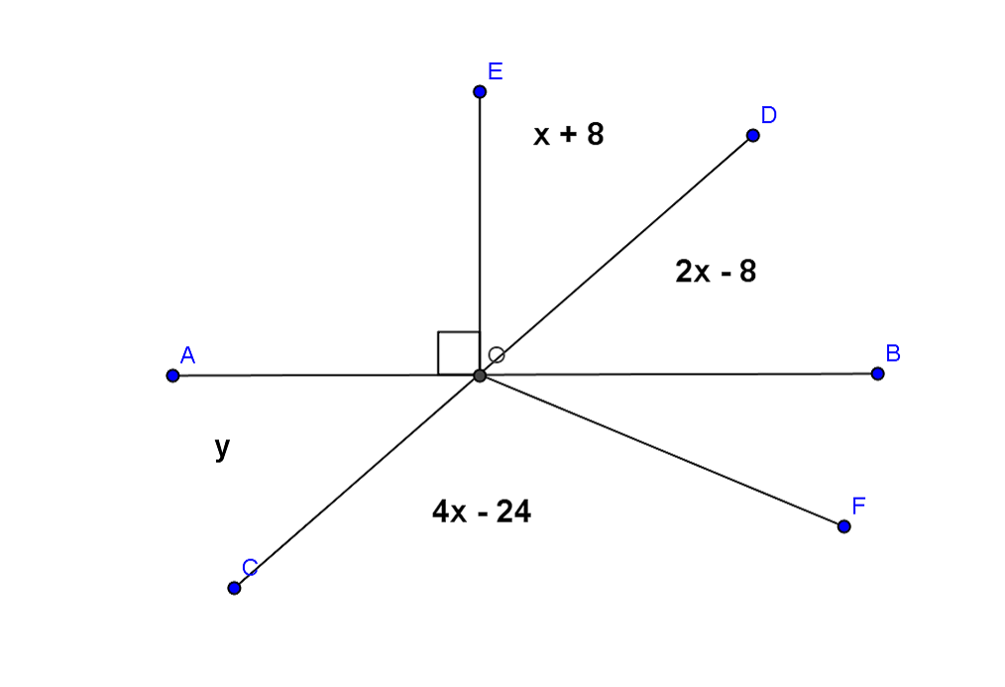
Classwork
Opening Exercise
Use the diagram at the right to determine $x$ and $y$. $AB$ and $CD$ are straight lines.
$x$ = ________
$y$ = ________
Name a pair of vertical angles:
_____________________

Find the measure of $∠BOF$. Justify your calculation. _____________________________________________________
_____________________________________________________

Discussion
Given a pair of lines $AB$ and $CD$ in a plane (see the diagram below), a third line $EF$ is called a transversal if it intersects $AB$ at a single point and intersects $CD$ at a single but different point. The two lines $AB$ and $CD$ are parallel if and only if the following types of angle pairs are congruent or supplementary:

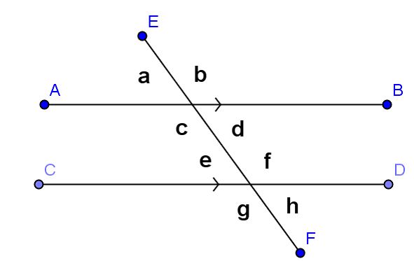
- Corresponding Angles are equal in measure
Abbreviation: ______
_____________________________________
- Alternate Interior Angles are equal in measure
Abbreviation: ______
_____________________________________
- Same Side Interior Angles are supplementary
Abbreviation: ______
_____________________________________

Examples
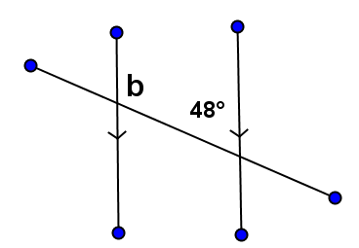
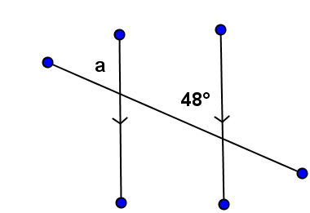
a. b.

$∠a$ = ________ $∠b$ = ________

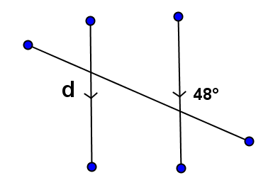
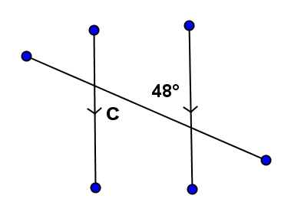
c. d.

$∠c$ = ________ $∠d$ = ________

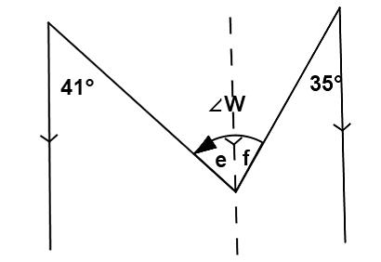
- An _________________________________is sometimes useful when solving for unknown angles.
In this figure, we can use the auxiliary line to find the measures of $∠e$ and $∠f$ (how?), then add the two measures together to find the measure of $∠W$.

What is the measure of $∠W$?

Exercises
In each exercise below, find the unknown (labeled) angles. Give reasons for your solutions.

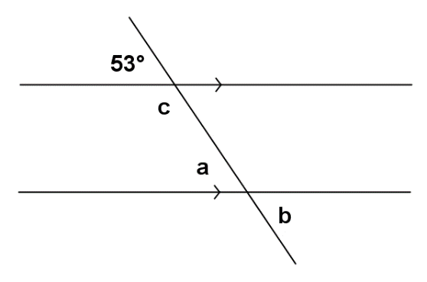
1. $∠a$ = ________________________

$∠b$ = ________________________

$∠c$ = ________________________

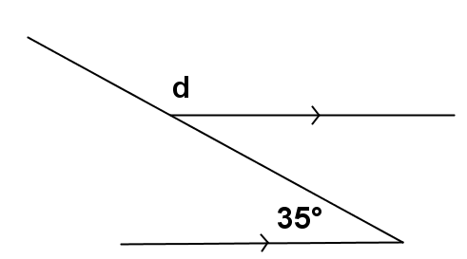
2.

$∠d$ = ________________________

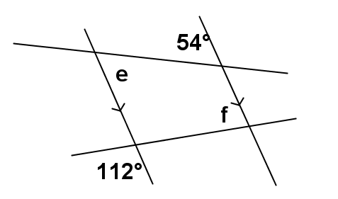
3. $∠e$ = ________________________

$∠f$ = ________________________

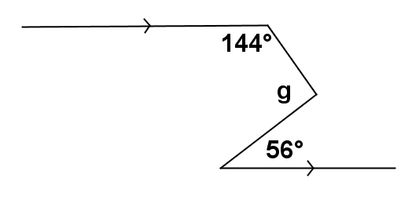
4.

$∠g$ = ________________________

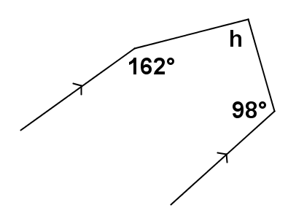
5. $∠h$ = ________________________

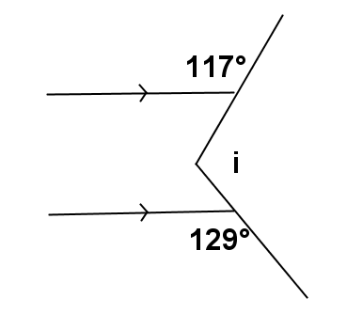
6. $∠i$ = ________________________

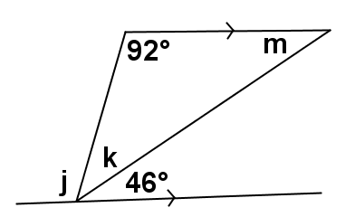
7. $∠j$ = ________________________

$∠k$ = ________________________

$∠m$ = _______________________

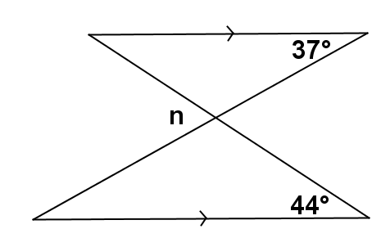
8.
$∠n$ = ________________________

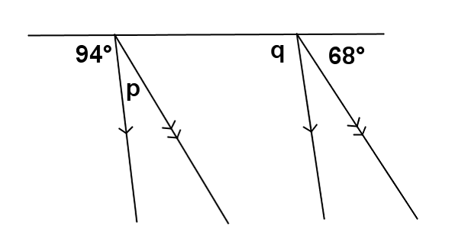
9. $∠p$ = ________________________

$∠q$ = ________________________

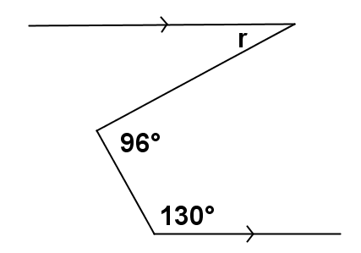
10.
$∠r$ = ________________________

Relevant Vocabulary
Alternate Interior Angles: Let line $T$be a transversal to lines $L$ and $M$ such that $T$intersects $L$ at point $P$and intersects $M$ at point $Q$. Let $R$ be a point on $L$, and $S$ be a point on $M$ such that the points $R$ and $S$ lie in opposite half-planes of $T$. Then the angle $∠RPQ$ and the angle $∠PQS$ are called alternate interior angles of the transversal $T$ with respect to $M$ and $L$.
Corresponding Angles: Let line $T$be a transversal to lines $L$ and $M$. If $∠x$ and $∠y$ are alternate interior angles, and $∠y$ and $∠z$ are vertical angles, then $∠x$ and $∠z$ are corresponding angles.

Problem Set

Find the unknown (labeled) angles. Give reasons for your solutions.

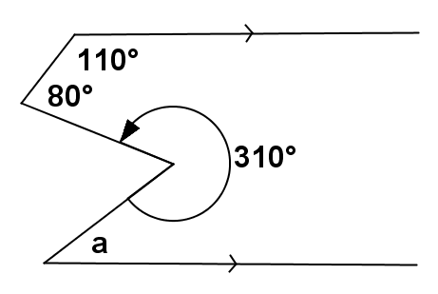
1.
$∠a$ = ________________________

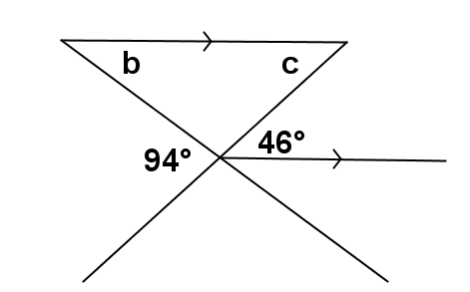
2. $∠b$ = ________________________

$∠c$ = ________________________

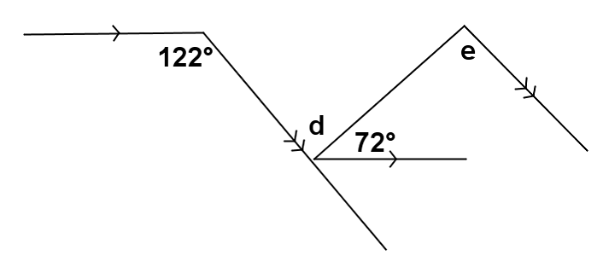
3. $∠d$ = ________________________

$∠e$ = ________________________

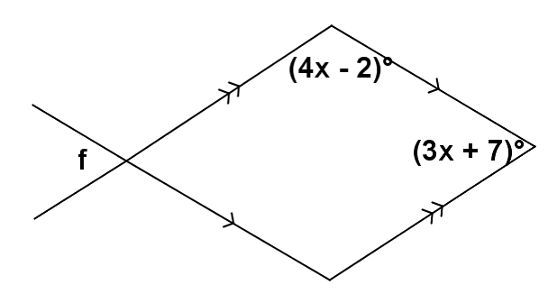

4. $∠f$ = ________________________

