|  |
| --- |
|  |

Lesson 7: Solve for Unknown Angles—Transversals

**Student Outcomes**

* Students review formerly learned geometry facts and practice citing the geometric justifications in anticipation of unknown angle proofs.

Lesson Notes

On the second day of unknown angle problems, the focus is on problems that involve parallel lines crossed by a transversal.

This lesson features one of the main theorems (facts) learned in 8th-grade:

1. If two lines are cut by a transversal and corresponding angles are equal, then the lines are parallel.
2. If parallel lines are cut by a transversal, corresponding angles are equal. (This second part is often called the Parallel Postulate. It tells us a property that parallel lines have. The property cannot be deduced from the definition of parallel lines.)

Of course, students probably remember these two statements as a single fact: For two lines cut by a transversal, corresponding angles are equal if and only if the lines are parallel. Teasing apart these two statements from the unified statement will be the work of later lessons.

The lesson begins with review material from Lesson 6. In the *Discussion* and *Exercises*, students review how to identify and apply corresponding angles, alternate interior angles, and same-side interior angles. The key is to make sense of the structure within each diagram (MP 7). The abbreviations associated with each relevant fact are important for fluency as lessons progress towards proofs.

Students learn examples of how and when to use auxiliary lines before moving on to the exercises. Again, the use of auxiliary lines is another opportunity for students to make connections between facts they already know and new information. The majority of the lesson involves solving problems. Gauge how often to prompt and review answers as the class progresses; check to see whether facts from Lesson 6 are fluent. Encourage students to draw in all necessary lines and congruent angle markings to help assess each diagram. The Problem Set should be assigned in the last few minutes of class.

Classwork

Opening Exercise (5 minutes)

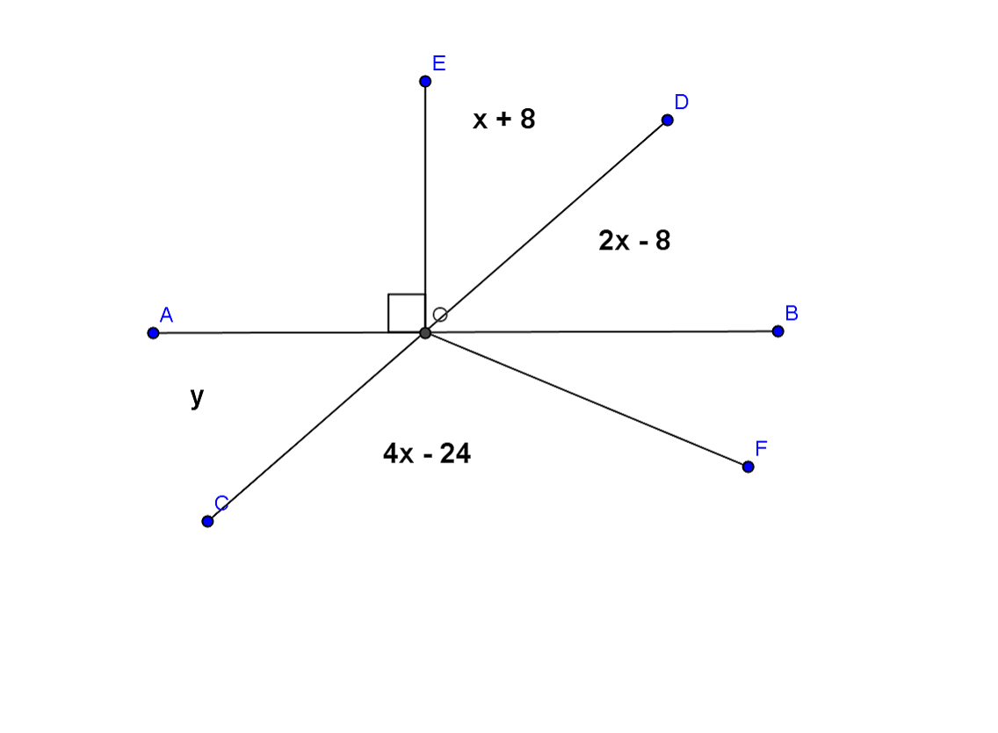  
Opening Exercise

Use the diagram at the right to determine $x$ and $y$. $AB$ and $CD$ are straight lines.

$$x=30˚$$

$$y=52˚$$

Name a pair of vertical angles:

$∠AOC$, $∠DOB$

Find the measure of $∠BOF$. Justify your calculation.

$∠BOF=32°$, ∠s on a line

Discussion (5 minutes)

Review the angle facts pertaining to parallel lines crossed by a transversal.

Discussion

Given a pair of lines $AB$ and $CD$ in a plane (see the diagram below), a third line $EF$ is called a *transversal* if it intersects $AB$ at a single point and intersects $CD$ at a single but different point. The two lines $AB$ and $CD$ are parallel if and only if the following types of angle pairs are congruent or supplementary:

* 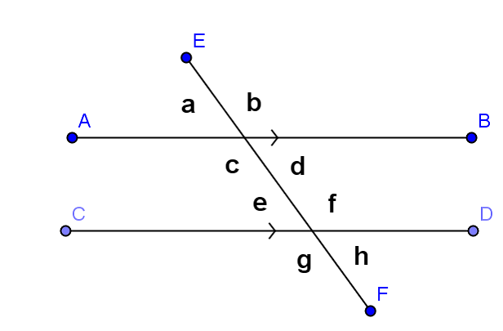Corresponding Angles are equal in measure

Abbreviation: **corr. ∠s**

∠a and ∠e , ∠d and ∠h, etc.

* Alternate Interior Angles are equal in measure

Abbreviation: **alt. ∠s**

**∠c and ∠f , ∠d and ∠e.**

* Same Side Interior Angles are supplementary

Abbreviation:  **int. ∠s**   
 **∠c and ∠e , ∠d and ∠f.**

Examples (8 minutes)

Students try examples based on *Discussion*; review, then discuss ‘auxiliary line’.

Examples

|  |  |
| --- | --- |
| **MP.7** |  |
|  |  |
|  |  |
|  |  |

* 1. 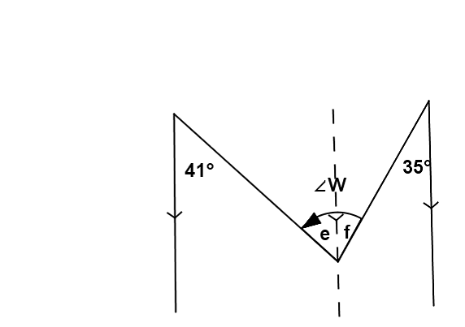An  **auxiliary line**  is sometimes useful when solving for unknown angles.

In this figure, we can use the auxiliary line to find the measures of $∠e$ and $∠f$ (how?), then add the two measures together to find the measure of $∠W$.

What is the measure of $∠W$?

$e=41°$, $f=35°$, $∠W=76°$

Exercises (30 minutes)

Students work on this set of exercises; review periodically.

Exercises

In each exercise below, find the unknown (labeled) angles. Give reasons for your solutions.

|  |  |
| --- | --- |
|  | $∠a=53°$, corr. ∠s $∠b=53°$ , vert. ∠s $∠c=127°$ , int. ∠s |
|  | $∠d=145°$, ∠s on a line, alt. ∠s |
| **MP.7** | $∠e=54°$, alt. ∠s $∠f=68°$ , vert. ∠s, int. ∠s |
|  | $∠g=92°$, vert. ∠s, int. ∠s |
|  | $∠h=100°$, int. ∠s |
|  | $∠i=114°$, ∠s on a line, alt. ∠s |

|  |  |
| --- | --- |
|  | , alt. ∠s $∠k=42°$ , ∠s on a line $∠m=46°$ , alt. ∠s |
|  | $∠n=81°$, corr. ∠s |
| **MP.7** | $∠p=18°$, ∠s on a line $∠q=94°$ , corr. ∠s |
|  | $∠r=46°$, int. ∠s, alt. ∠s |

Relevant Vocabulary (2 minutes)

Relevant Vocabulary

Alternate Interior Angles: Let line $T$ be a transversal to lines $L$ and $M$ such that $T$ intersects $L$ at point $P$ and intersects $M$ at point $Q$. Let $R$ be a point on $L$ and $S$ be a point on $M$ such that the points $R$ and $S$ lie in opposite half-planes of $T$. Then the angle $∠RPQ$ and the angle $∠PQS$ are called *alternate interior angles* of the transversal $T$ with respect to $M$ and $L$.

Corresponding Angles*:* Let line $T$ be a transversal to lines $L$ and $M$.If $∠x$ and $∠y$ are alternate interior angles, and $∠y$ and $∠z$ are vertical angles, then $∠x$ and $∠z$ are *corresponding angles*.

Exit Ticket (5 minutes)

Name ___________________________________________________ Date____________________

Lesson 7: Solving for Unknown Angles—Transversals

Exit Ticket



$x=$

$y=$

$z=$

__________

__________

__________

Exit Ticket Sample Solutions



$x=40°$

$$y= 113°$$

$$z= 67°$$

Problem Set Sample Solutions

**MP.7**

Find the unknown (labeled) angles. Give reasons for your solutions.

|  |  |
| --- | --- |
|  | $∠a=40°$, int. ∠s, alt. ∠s |
|  | $∠b=48°$, corr. ∠s $∠c=46°$ , vert. ∠s, corr. ∠s |

|  |  |
| --- | --- |
|  | , alt. ∠s $∠e= 50°$ , alt. ∠s |
| **MP.7** | $∠f=82°$, int. ∠s, vert. ∠s |