Lesson 26: Triangle Congruency Proofs—Part I

Student Outcomes
- Students complete proofs requiring a synthesis of the skills learned in the last four lessons.

Classwork
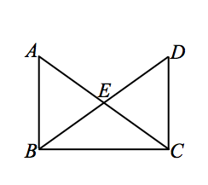
- Given: $\overline{AB}⊥\overline{BC}, \overline{BC}⊥\overline{DC}$.
$\overline{DB}$ bisects $∠ABC$, $\overline{AC}$ bisects $∠DCB.$
$\overline{EB}⋍\overline{EC}.$
Prove: $△BEA≅△CED.$
$\overline{AB}⊥\overline{BC}$, $\overline{BC}⊥\overline{DC}$ Given
$m∠ABC=90˚$, $m∠DCB=90˚$ Def. of perpendicular
$\overline{DB}$ bisects $∠ABC$, $\overline{AC}$ bisects $∠DCB$ Given
$m∠ABE=45˚$, $m∠DCE=45˚$ Def. of bisect
$m∠ABE=m∠DCE$ Transitive Property of = (Substitution)
$∠ABE⋍∠DCE$ Def. of congruent angles
$\overline{EB}⋍\overline{EC}.$ Given
$∠AEB and ∠DEC$ are vertical angles Definition of Vert. $∠s$
$∠AEB ⋍∠DEC$ Vert. $∠$ Theorem
$△BEA≅△CED$ ASA

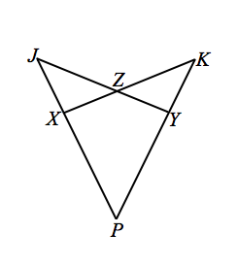
- Given: $\overline{XJ}⋍\overline{YK}, \overline{PX}⋍\overline{PY}, ∠ZXJ⋍∠ZYK.$
Prove: $\overline{JY}=\overline{KX}$.
$\overline{XJ}⋍\overline{YK}, \overline{PX}⋍\overline{PY}, ∠ZXJ⋍∠ZYK.$ Given
$∠JZX and ∠KZY$are vertical angles Definition of Vert. $∠s$
$∠JZX⋍∠KZY$ Vert. $∠ Theorem$
$△JZX≅△KZY$ SAA (AAS)

$∠J⋍∠K$ Corresponding Parts of Congruent Triangles are Congruent (CPCTC)
$∠P⋍∠P$ Reflexive Property
$\overline{JP}⋍\overline{PK}$ When congruent segments are added to congruent segments, the sums are conguent
$△PJY≅△PKX$ SAA
$\overline{JY}=\overline{KX}$ CPCTC

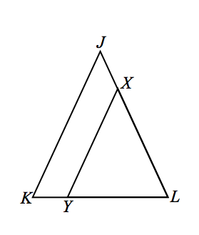
- Given: $\overline{JK}⋍\overline{JL}, \overline{JK}∥\overline{XY}.$
Prove: $\overline{XY}⋍\overline{XL}.$
$\overline{JK}⋍\overline{JL}$ Given
$∠K⋍∠L$ Base $∠s$in isos. $△$are congruent
$\overline{JK}∥\overline{XY}$ Given
$∠K⋍∠Y$ Corr. $∠s$ are congruent since $\overline{JK}∥\overline{XY}$
$∠Y⋍∠L$ Substitution/Transitive
$\overline{XY}⋍\overline{XL}$ Base $∠s$ converse

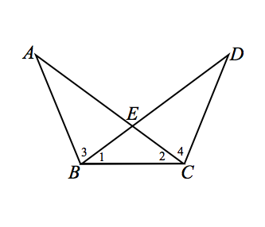
- Given: $∠1⋍∠2, ∠3⋍∠4.$
Prove: $\overline{AC}⋍\overline{BD}$.
$∠1⋍∠2$ Given
$\overline{BE}⋍\overline{CE}$ Base $∠s$ converse
$∠3⋍∠4$ Given
$∠AEB and ∠DEC$ are vertical angles Definition of Vert. $∠s$
$∠AEB⋍∠DEC$ Vert. $∠s$ Theorem
$△ABC≅ △DCB$ ASA
$∠A⋍∠D$ CPCTC
$\overline{BC}⋍\overline{BC}$ Reflexive Property
$△ABC≅ △DCB$ SAA
$\overline{AC}⋍\overline{BD}$ CPCTC

OR

$∠1⋍∠2$ Given
$\overline{BE}⋍\overline{CE}$ Base $∠s$ converse
$∠3⋍∠4$ Given
$∠AEB and ∠DEC$ are vertical angles Definition of Vert. $∠s$
$∠AEB⋍∠DEC$ Vert. $∠s$ Theorem
$△ABC≅ △DCB$ ASA
$\overline{AE}⋍\overline{ED}$ CPCTC
$\overline{AC}⋍\overline{BD}$ If congruent segments are added to congruent segments, then their sums are congruent

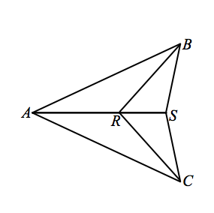
- Given: $\overline{AB}≅\overline{AC},$
$\overline{RB}≅\overline{RC},$
Prove: $\overline{SB}≅\overline{SC}.$

$\overline{AB}≅\overline{AC}$, $\overline{RB}≅\overline{RC}$ Given
$\overline{AR}≅\overline{AR}$ Reflexive Property
$△ARC≅△ARB$ SSS
$∠ARC≅∠ARB$ CPCTC
$∠ARC and ∠SRC$ form a linear pair Definition of a linear pair
$∠ARB and ∠SRB$ form a linear pair
$∠ARC and ∠SRC$ are supplementary Linear Pair Theorem
$∠ARB and ∠SRB$ are supplementary
$∠SRC≅∠SRB$ supplements of congruent angles are congruent
$\overline{SR}=\overline{SR}$ Reflexive Property
$△SRB≅△SRC$ SAS
$\overline{SB}≅\overline{SC}$ CPCTC

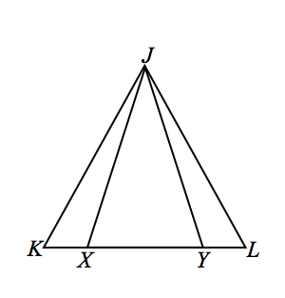
- Given: $\overline{JK}≅\overline{JL}, \overline{JX}≅\overline{JY}.$
Prove: $KX=LY$.
$\overline{JX}≅\overline{JY}$ Given
$∠JXY≅∠JYX$ Isosceles Triangle Theorem
$∠JXK and ∠JXY$ form a linear pair Definition of Linear Pair
$∠JYL and ∠JYX$ form a linear pair
$∠JXK and ∠JXY$ are supplementary Linear Pair Theorem
$∠JYL and ∠JYX$ are supplementary
$∠JXK≅∠JYL$ Supplements to congruent angles are congruent
$\overline{JK}≅\overline{JL}$ Given
$∠K≅∠L$ Isosceles Triangle Theorem
$△JXK≅△JYL$ SAA
$\overline{KX}≅\overline{LY}$ CPCTC

- Given: $\overline{AD}⊥\overline{DR}, \overline{AB}⊥\overline{BR}$,
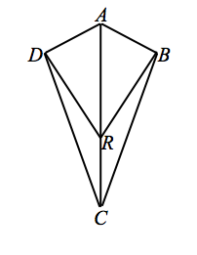
$\overline{AD}≅\overline{AB}.$
Prove: $∠DCR≅∠BCR.$
$\overline{AD}⊥\overline{DR}, \overline{AB}⊥\overline{BR}$, Given
$∠ADR and ∠ABR are right angles$ Definition of perpendicular lines
$△ADR and △ABR are right triangles$ Definition of right triangle
$\overline{AD}≅\overline{AB}$ (Leg) Given
$\overline{AR}≅\overline{AR}$ (Hypotenuse) Reflexive Property
$△ADR≅△ABR$ Hypotenuse Leg (HL)
$∠ARD≅∠ARB$ Corr. $∠$s of $≅△$ (CPCFC/CPCTC) $∠ARD and ∠DRC are a Linear Pair Definition of Linear Pair$
$∠ARB and ∠BRC are a Linear Pair$ $∠ARD and ∠DRC are Supplementary Linear Pair Theorem$
$∠ARB and ∠BRC are Supplementary$

$∠DRC≅∠BRC$ Supplements of congruent angles are congruent
$\overline{DR}≅\overline{BR}$ Corr. sides of $≅△$ (CPCFC)
$\overline{RC}≅\overline{RC}$ Reflexive Property
$△DRC≅△BRC$ SAS
$∠DCR≅∠BCR$ Corr. $∠$s of $≅△$ (CPCFC)

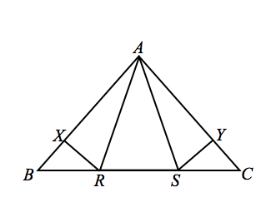
- Given: $\overline{AR}≅\overline{AS}, \overline{BR}≅\overline{CS},$
$\overline{RX}⊥\overline{AB}, \overline{SY}⊥\overline{AC}.$
Prove: $\overline{BX}≅\overline{CY}.$
$\overline{AR}≅\overline{AS}$ (S) Given
$∠ARS≅∠ASR$ Base $∠$s of isos. $△ ≅(ITT)$
$∠ARS and ∠ARB$ are a Linear Pair $Def. of a Linear Pair$
$∠ASR and ∠ASC are a Linear Pair$
$∠ARS and ∠ARB$ are Supplementary $Linear Pair Theorem$
$∠ASR and ∠ASC are Supplementary$
$∠ARB≅∠ASC$ (A) Supplements of congruent angles are congruent
$\overline{BR}≅\overline{CS}$ (S) Given
$△ARB≅△ASC$ SAS
$∠ABR≅∠ACS$ (A) Corr. $∠$s of $≅△$ (CPCFC/CPCTC)
$\overline{RX}⊥\overline{AB}, \overline{SY}⊥\overline{AC}$ Given
$∠RXB and ∠SYC$ are right angles Def. of perpendicular
$∠RXB≅∠SYC$ (A) If two angles are right angles then they are congruent
$△BRX≅△SYC$ SAA
$\overline{BX}≅\overline{CY}$ Corr. sides of $≅△$ (CPCFC)

